**t -Retail**



**HR ORBIT**

**SONALI INTELLECT LIMITED**

**BUSINESS REQUIREMENT DOCUMENT OF**

**PERFORMENCE APPRAISAL**

**COPYRIGHT NOTICE**

**Copyright © 2022, Sonali Intellect Limited**

**All rights reserved.**

These materials are confidential and proprietary to Sonali Intellect Limited and no part of these materials should be reproduced, published, transmitted or distributed in any form or by any means, electronic, mechanical, photocopying, recording or otherwise, or stored in any information storage or retrieval system of any nature nor should the materials be disclosed to third parties without the prior express written authorization of Sonali Intellect.

**Revision History**

|  |  |  |  |  |  |
| --- | --- | --- | --- | --- | --- |
| **Version** | **Published Date** | **Description of changes** | **Author** | **Reviewed By** | **Approved By** |
| 1.0.0 | 09-01-2025 |  | Faiyaz Masrur, Nafisa Ahmed Progga |  |  |

**TABLE OF CONTENTS**

1 INTRODUCTION 3

1.1 Purpose of the Document 3

1.2 References 3

1.3 Terminology 4

1.3.1 Field Rule Properties 4

1.3.2 Field Type 5

1.3.3 Data Element 5

1.3.4 Acronyms & Abbreviations 6

2 PROJECT OVERVIEW 7

3 PREREQUISITES 8

4 BUSINSESS REQUIREMENT 8

4.1 Application Authentication and Access 8

4.1.1 User Journey 8

4.2 Employee Repository 9

4.2.1 User Journey 9

4.3 Performance Appraisal Workflow 9

The performance appraisal process will follow a defined hierarchy: 9

4.3.1 User Journey 9

4.4 Notifications 10

4.4.1 User Journey 10

5 Flow Chart 11

6 USER INTERFACES 11

# INTRODUCTION

## Purpose of the Document[1]

This document describes the functionality and business requirements for the HR Orbit Performance Appraisal system. The system is designed to digitize and automate the manual performance review process at Sonali Intellect, managing the entire appraisal lifecycle from employee self-appraisal to final approval by CEO.

The intended audiences for this document are:

1. Business Users
2. Testers
3. Technical Architects & Developers

## References

|  |  |
| --- | --- |
| **Document Name** | **Description** |
| Style Sheet Document | For the common GUI requirement |
| UI/UX Document | For the UI of various business functions |

## Terminology

### Field Rule Properties

This section lists down field type and field rule description

|  |  |
| --- | --- |
| **Code** | **Description** |
| R | Required |
| O | Optional |
| C | Conditional |
| CR | Conditionally Required |
| OOR | One of Fields Required |
| CE | Conditionally enabled (but not mandatory under that condition) |
| CD | Conditionally Disabled |
| H | Hidden |
| AP | Auto populated |
| CO | Conditional Optional (is optional under a condition else will not accept input) |
| CM | Conditional Mandatory (is mandatory under a condition else should not accept input) |
| NA | Not applicable |

### Field Type

|  |  |
| --- | --- |
| **Code** | **Description** |
| F | Free format input (text box/text area) |
| P | Password |
| DD | Single select drop-down list of values |
| CB | Checkbox |
| RO | Read only |
| F | File upload |
| D | Date (provides a calendar for selecting) |
| T | Text (single line text input) |
| N | Number (numeric input) |
| TA | Textarea (multi-line text input) |
| AF | Already-filled (read-only, auto-populated) |

### Data Element

|  |  |  |  |  |  |
| --- | --- | --- | --- | --- | --- |
| **Data Type** | **Description** | **Allowed Characters** | | | |
| NUM/N (XX) | Number | 0 to 9 |  |  |  |
| AN | Alphanumeric | a to z | A to Z | 0 to 9 |  |
| A | Alphabet | a to z | A to Z |  |  |
| DAT | Date (DD/MM/YYYY) | 0 to 9 | - | / |  |
| DATM | Date/Time (DD/MM/YYYY)  For time (HH:MM: SS AM/PM) | 0 to 9 | - | / | : |
| DATMZ | Date/Time with time zone | 0 to 9 | / | : | A to Z |
| TXT (XX) | Text | a to z A to Z 0 to 9 Space ! @ # $ % | ^ & * ( ) - _ + = | ` ~ | \ { } [ ] < | > ' ? " ; . , : / |

### Acronyms & Abbreviations

|  |  |  |
| --- | --- | --- |
| **S N** | **Term** | **Explanation** |
| 1 | BRD | Business Requirements Document |
| 2 | BPD | Business Process Diagram |
| 3 | SRS | Software Requirements Specification |
| 4 | SDLC | Software Development Life Cycle |
| 5 | UI/UX | User Interface/User Experience |
| 6 | HOD | Head of Department |
| 7 | COO | Chief Operating Officer |
| 8 | CEO | Chief Executive Officer |
| 9 | PP | Pay Progression |
| 10 | API | Application Programming Interface |
| 11 | JWT | JSON Web Token |
| 12 | CORS | Cross-Origin Resource Sharing |
| 13 | POST | Power On Self Test |
| 14 | CSRF | Cross Site Request Forgery |
| 15 | REST | Representational State Transfer |
| 16 | ORM | Object Relational Mapping |

# PROJECT OVERVIEW

Sonali Intellect is developing an HR Orbit Performance Appraisal Module to automate the multi-level performance review process. Key features will include role-based access, automated salary calculations, a tiered review hierarchy, and PDF generation of completed forms. The project aims to enhance clarity, improve communication, and ensure consistent documentation across the organization.

The system's development will follow a specific SDLC model:

1. Documentation:
   1. BRD – Business Requirement Documentation
   2. BPD – Business Process Documentation
   3. SRS – Software Requirement Specification
   4. Scope Document
2. Planning:
   1. Data field definition
   2. Diagrams & Designs:
      1. Software Architecture Design
      2. Schema Design
      3. Activity Diagram
      4. Class Diagram
      5. Data Flow Diagram
      6. Components Diagram
      7. Context Diagram
3. UI/UX design
4. Development
5. Testing
6. Deployment, and Maintenance.

# PREREQUISITES

Key elements and prerequisites for using Application functionalities:

1. Only existing employees who have been authorized to use the Performance Appraisal can use this functionality.

# BUSINSESS REQUIREMENT

For the first phase of development, it was amicably agreed by Stakeholder, Management and the Scrum Team that the following functionalities will be developed.

## Application Authentication and Access

The system will provide secure logins for the users:

1. Employee
2. Manager
3. HR
4. HOD
5. COO
6. CEO
7. Admin (HR)

### User Journey

* First, the Admin must create accounts for all the users and share the login credentials.
* To log in, a user must provide a username (text) and a password (password).
* A Forgot Password functionality will allow users to reset their password via a link sent to their email.
* Users will be able to change their password after login from their profile page.
* Each person will have edit access only to their designated part of the form and view access to the rest.

## Employee Repository

The system will maintain a central repository of employee data.

### User Journey

* While creating a user, the Admin/Hr. will add mandatory fields:

1. Employee ID (4 digit)
2. Name
3. Designation (from specified dropdown list)
4. Department (from specified dropdown list)
5. Date of Joining (date)
6. Grade
7. Salary (basic)
8. Reporting Manager

* Employees must fill specific fields on their profile page:

1. Responsibilities
2. Previous Working Experience
3. Education Qualification- text field (attachment)
4. Professional Certificate - text field (attachment)
5. Image (file)

## Performance Appraisal Workflow

## The performance appraisal process will follow a defined hierarchy:

Employee ----> Manager ----> HR ----> HOD ----> COO ----> CEO

### User Journey

* The employee fills out their section of the form. Fields include:

1. Achievement / Goal Completion (text area)
2. Training & Development Plan questions (text area and checkbox)
3. Date

* The manager reviews the employee's section and provides their own feedback. Fields include:

1. Comments on Achievement and Goal Completion and Training and Development Plan (text area).
2. Overall Assessment rating with a text field for justification.
3. Potential for Growth rating with a text field for remarks.
4. Date (date)

* HR validates the review and inputs salary details.

1. They will input the basic salary, and the gross salary and increment will be calculated automatically (table)
2. HR also has a decision table for promotion and increment recommendations
3. Add Date (date)

* HOD, COO, CEO, these are subsequent levels of approval.

1. They will confirm their agreement to the review and provide remarks (text area)
2. They will also use a decision table to recommend promotion and increment (table)
3. Add Remarks on their decision. (text area)
4. Add date of the review. (date)

## Notifications

### User Journey

* The system shall send notifications to the next level of the hierarchy when a form is submitted
* Notifications will be sent one week before the form submission due date
* After the deadline, the form's view and edit access will be closed

## 5 Flow Chart

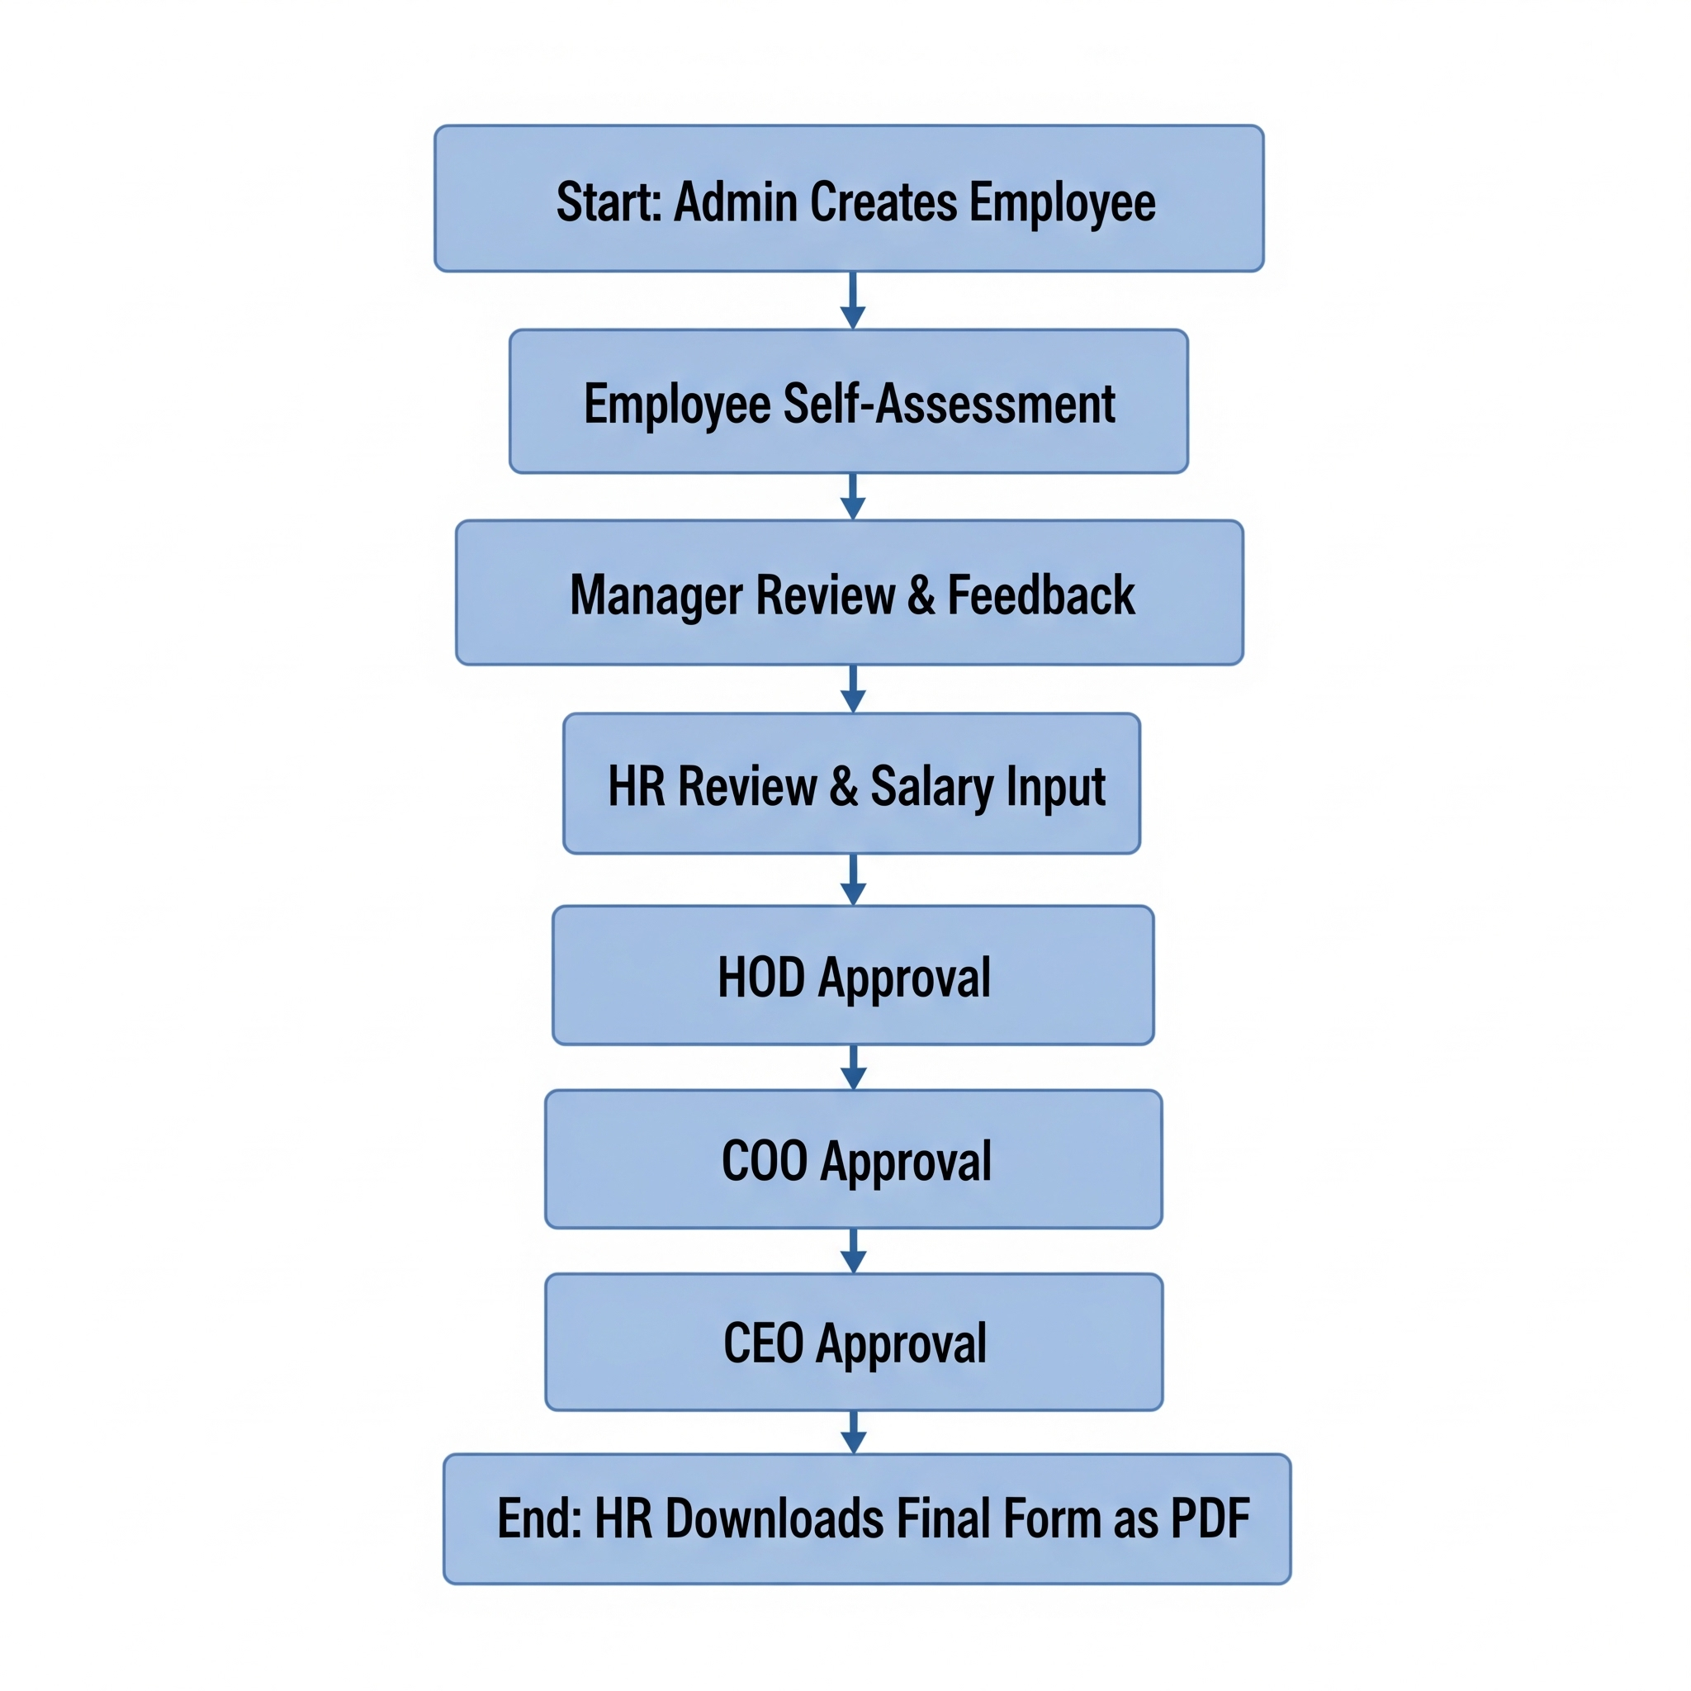

## 6 USER INTERFACES

* **Login Page:** A secure login page with fields for Employee ID and password, a 'Forgot Password' link, and a password reset page.
* **Dashboard:** The dashboard will have a left panel for the appraisal form, a middle section to display the form, and a right panel to list pending review forms for supervisees.
* **User Profile:** A profile page will display all employee repository information, with an option to edit the specific editable fields and change the password.
* **Notifications:** A notification icon on the top right of the navbar will display pop-up notifications for pending reviews and deadlines.
* **Document Generation:** A button or option for HR to download the final, completed appraisal form as a PDF.

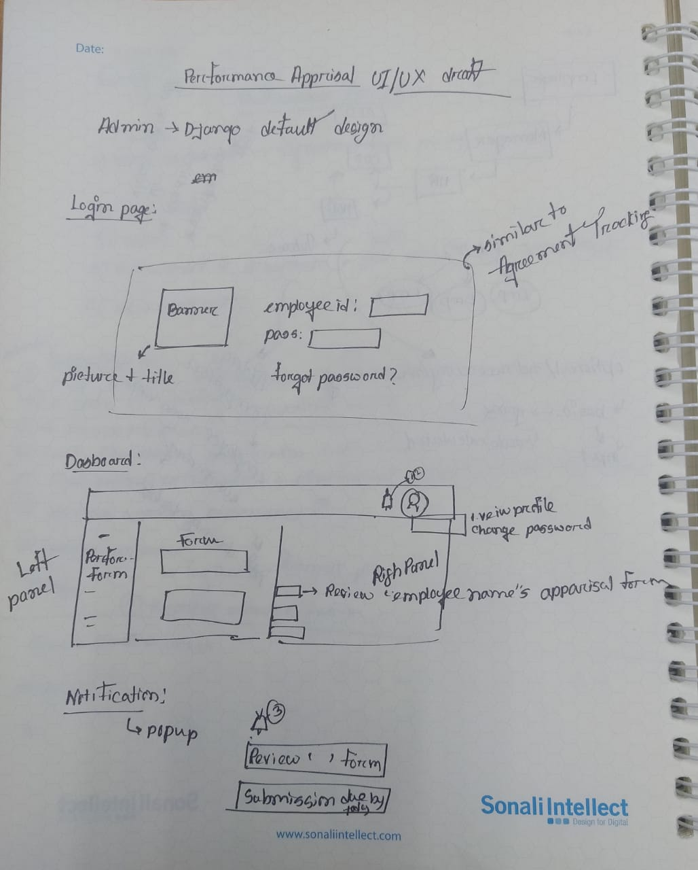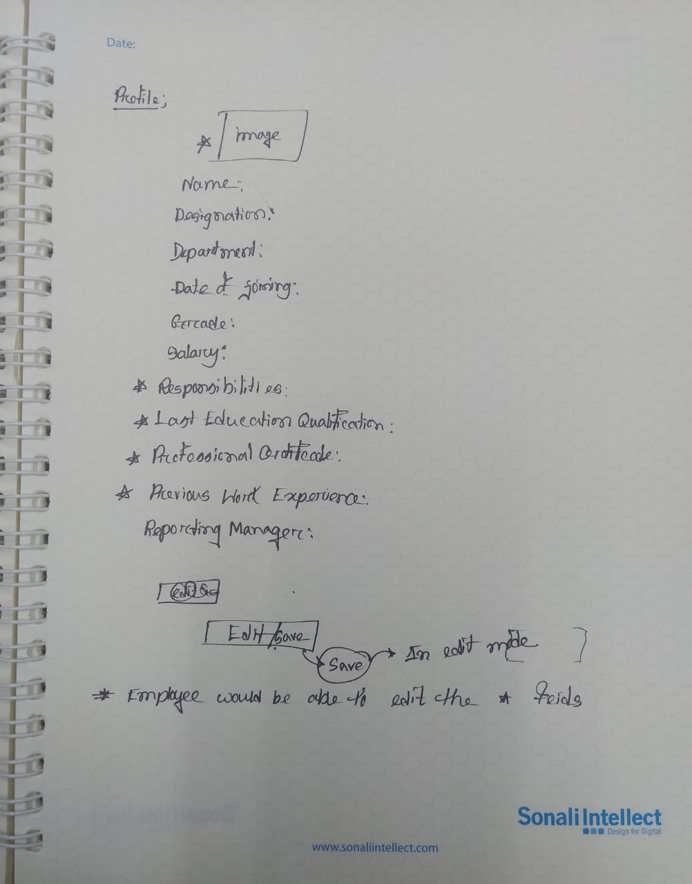

1. **Disclaimer:** *The screen layouts provided in the document are solely for depicting the functionality of the application. The actual look and feel of the application may vary according to the branding, theme and data field definitions specific to the implementation.*

   *Document will contain product screenshot and the Data Definition Section for each screen will specify the gaps like removed field, new fields, or field label text change.*